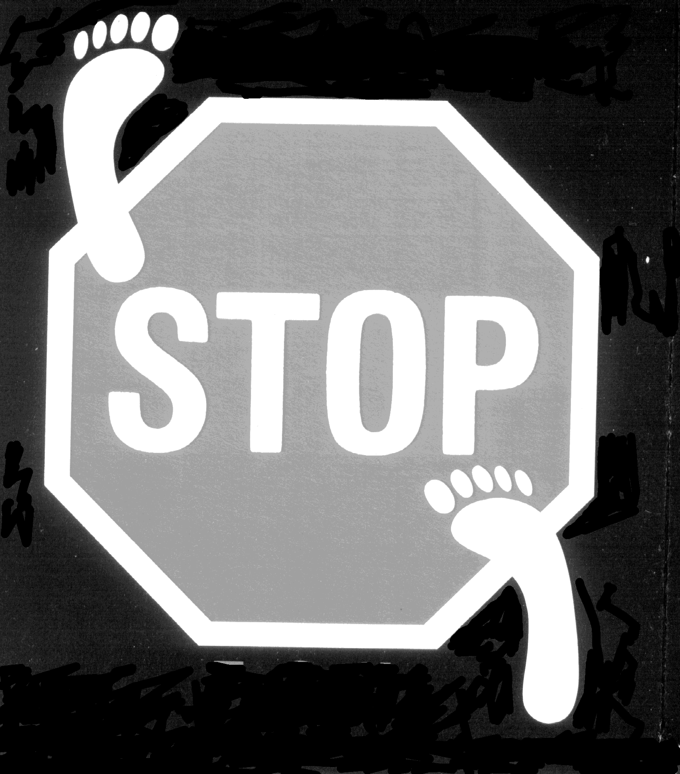

MYKORED VERRUCAE ?

MYKORED for the treatment of verrucae and fungal infections of the skin and nail. Can be used on children. Suitable for sensitive skin.

APPLICATION INSTRUCTIONS

VERRUCAE

Apply twice daily, directly onto the verruca, or a cotton bud dipped in MYKORED may be used for application, otherwise for difficult areas soak a small piece of cotton wool and tape it on (It may be left like this for up to 2 hours).
To increase the effectiveness of the treatment it is recommended that your chiropodist removes the top layer of the verrucae at your initial consultation and review progress every 2 -3 weeks.

Once the MYKORED has been applied no dressing is required. MYKORED will dry the verruca out and may cause it to lift up or even come away completely. When MYKORED has been applied any pain will reduce rapidly.

FUNGAL INFECTIONS

Apply MYKORED directly on the infected area at least once daily, again you might find it useful to use a cotton bud dipped in MYKORED. For fungal infections of the nail, holding the toe vertically and dripping Mykored at the tip of the toe will allow the fluid to run under the nail and down the sides of the nail bed. The length of time needed to treat the infection will vary based on the severity of the infection and the age of the patient. Nail infections take many months before the healthy growth replaces the infected area. Your chiropodist will advise you based on your personal progress.

MYKORED can safely be applied to healthy skin and nails, it will not cause damage. Consult your chiropodist if you experience any reaction. It can also be safely used with other medication. Pregnant women should always consult their chiropodists or doctors before using any medication.

MYKORED is available in easy spray pump action bottles or pipette dropper bottles.
The spray is particularly useful for regular swimmers providing protection against infection. It is also suitable for application to socks and shoes preventing re-infection.
Chiropodist
UK Distributor to Chiropodists only:

Hilary Supplies
34A Halstead Rd, Mountsorrel,
Leics LE12 7HF

